- Abstract
- Intro- bistability in perception often shows buildup (auditory specific or general – list examples?)
- Methods
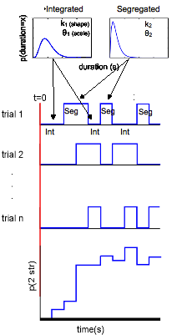
  - ARP model- imagine z(t) is a random variable representing whether or not a percept is split at a particular moment in time. Thus z takes on values {0,1}; when z = 0, the percept is grouped, and when z = 1, the percept is split. These states of z have corresponding random durations T0 and T1. The initial value z(0) is known to always be 0. The durations T1 and T0 are gamma distributed, such that

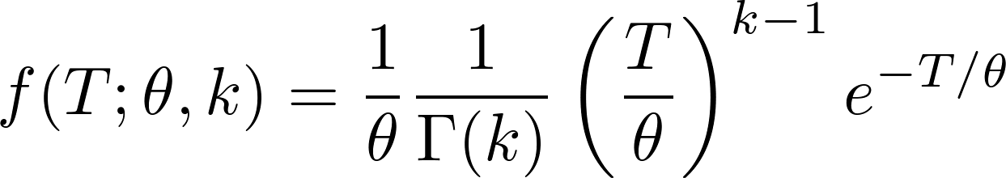

The distribution of durations of grouped percepts, T0, has parameters 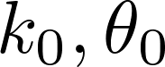 and the parameters for the distribution of durations of split percepts, T1 are 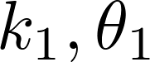. A solution exists for , aka the buildup function. We can write this solution analytically in the Fourier domain as
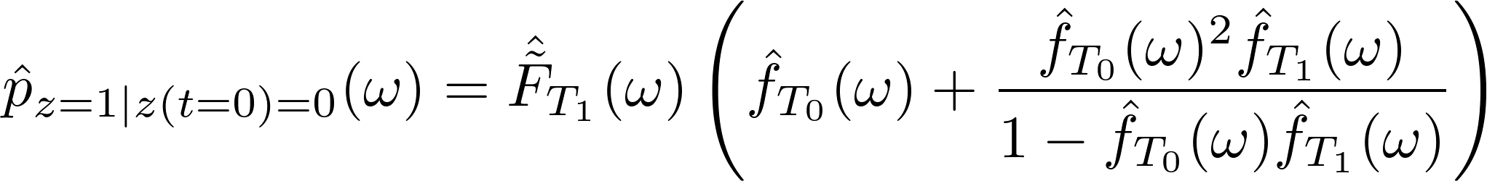
where 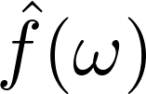 is the Fourier transform of the gamma distribution, 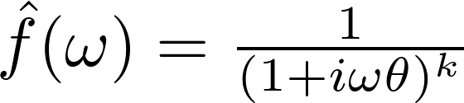 and 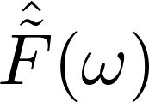 is the Fourier transform of the complementary cumulative distribution function, 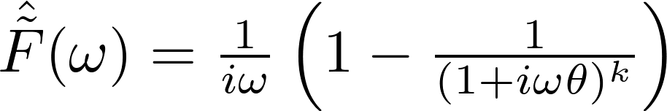.
  - competition model- ad hoc neuronal-like network
    - description:
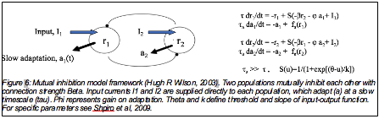
    - analysis:
- The simulated timecourses of population firing rates were converted to binary timecourses relating when one population's firing rate was higher than the other's, and from these we calculated the distribution of dominance durations.
- The population with the first dominance epoch was arbitrarily labelled “coherent,” except when the input current to each population was mismatched. In this case, one population was always labelled “coherent”, and simulation runs in which the other population attained dominance first by chance were discarded. [THIS BIT CAN BE DONE BETTER WITH HARD CODE]
- We averaged over switches into integration to produce buildup functions [REDO WITH TRIAL AVERAGING], and used MLE gamma parameters from the dominance duration distributions to generate ARP predictions.
    - Regimes:
    - high vs low adaptation gain constant
    - high vs low noise
    - mismatched inputs
- Results
  - correlations
  - high correlations violate assumptions of ARP model and many previous published results, but they are predicted by adaptation-driven switching
  - ARP model does a good job of fitting BUFs even with correlated gamma distributions, but those BUFs are strange looking
2. Non-monotonicity
    - periodicity increases the chance that events over different trials will occur at close to the same time, eg percept epochs will line up across trials
    - adaptation in the absence of noise increases this periodicity
    - can be reduced by making sure the ratio of variance to the mean is high enough, eg adding noise to overwhelm adaptation effects [LOOK TO SEE IF THERE'S AN EASY WAY TO QUANTIFY THIS, LIKE HIGH ALPHA]

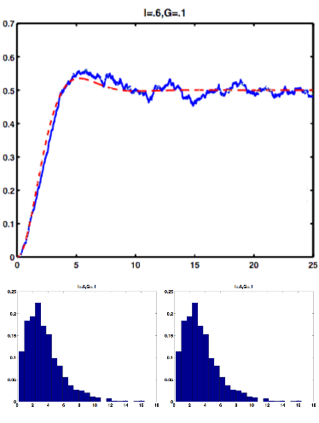
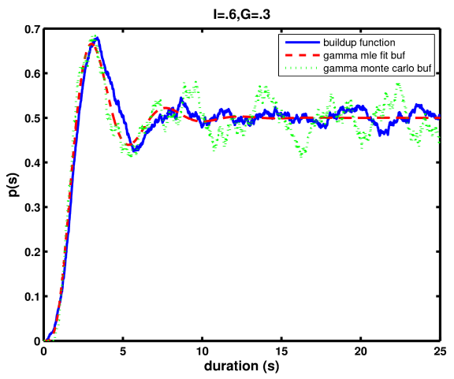

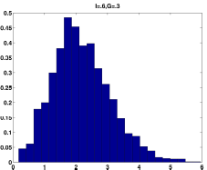
- Discussion-
- [CHECK TO SEE IF THIS IS THE FIRST COMPETITION MODEL BUF OUT THERE]
- adding noise makes more monotonic, shorter mean duration
- increasing adaptation makes more periodic

- Conclusions

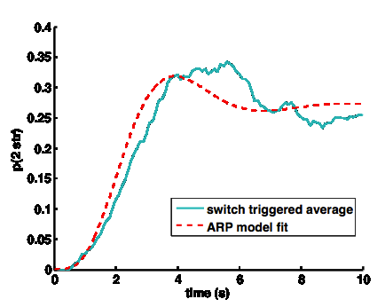
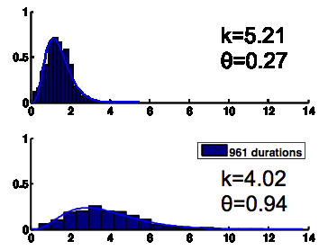
I1 = 0.7, I
2 = 0.55

